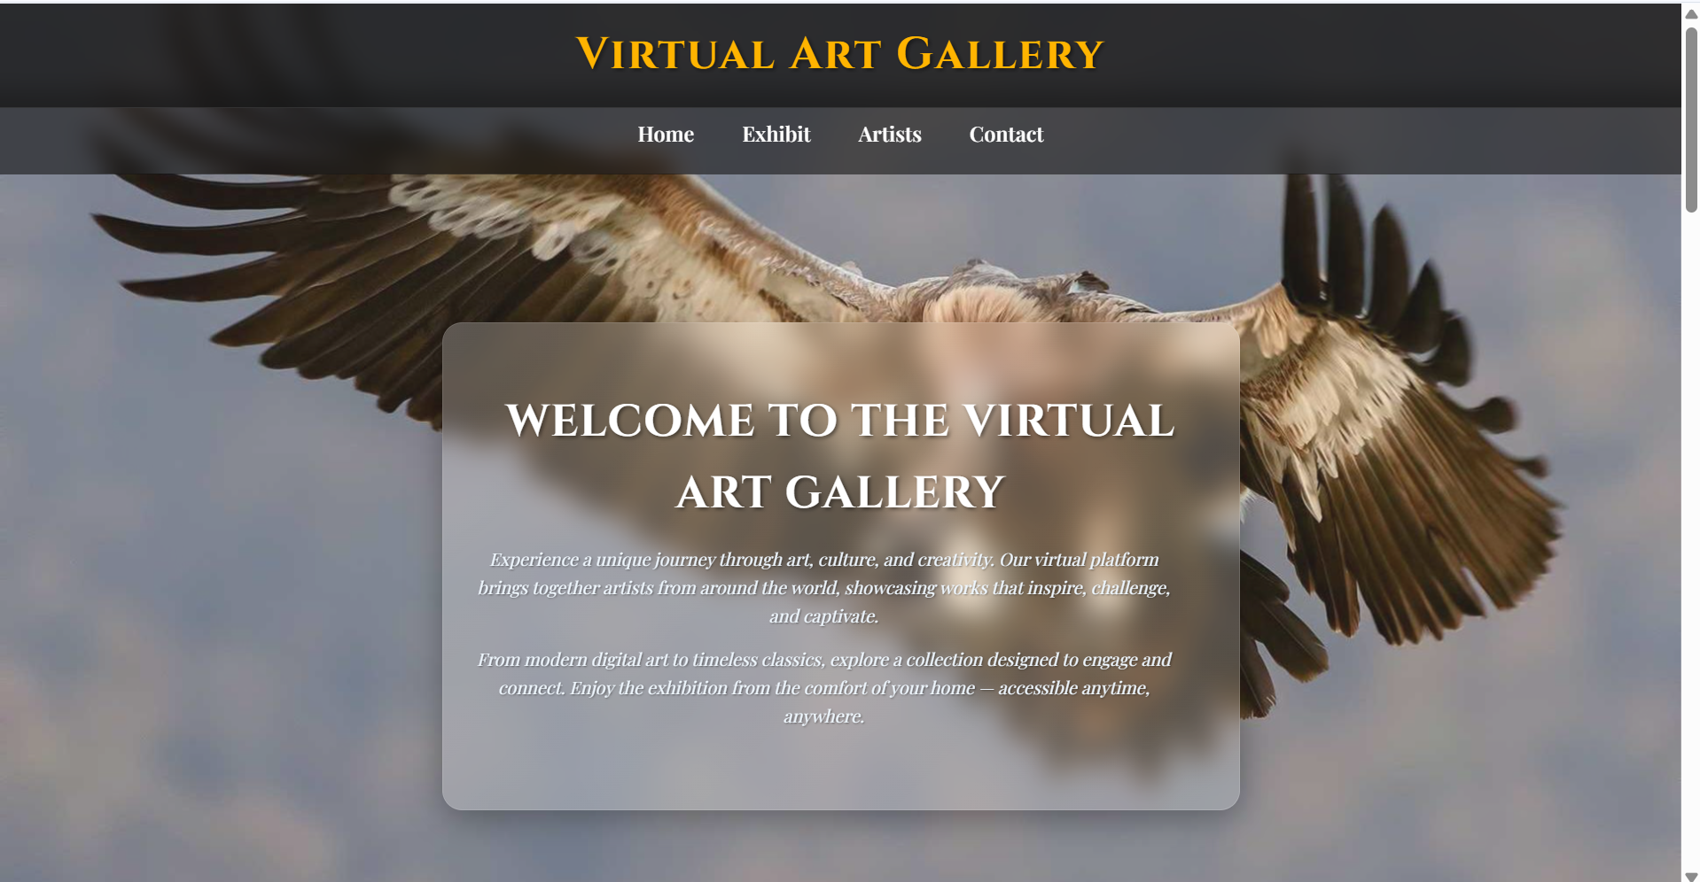

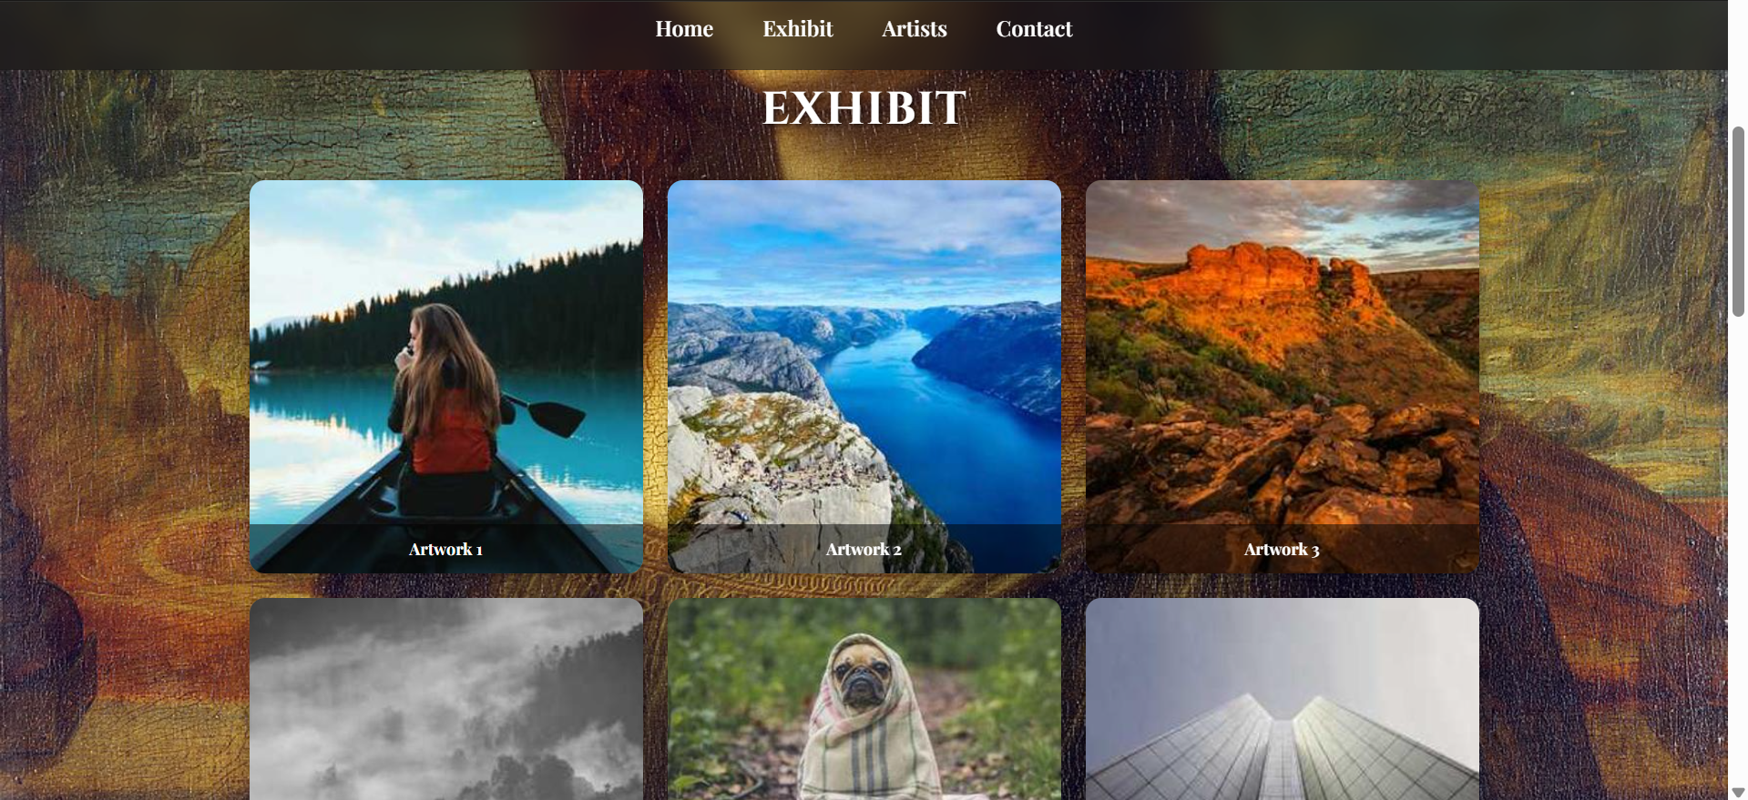

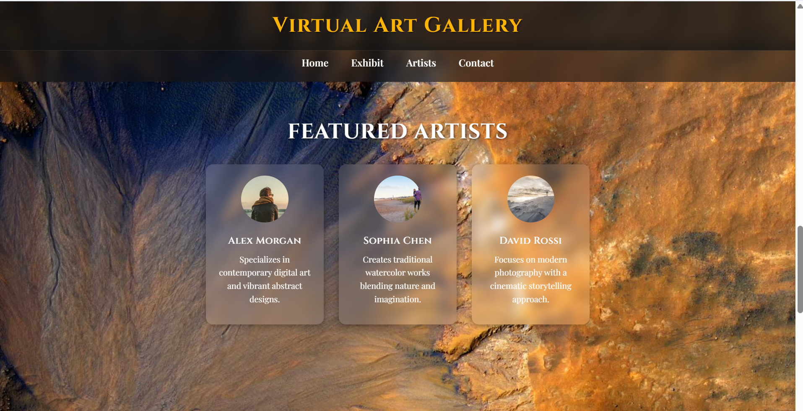

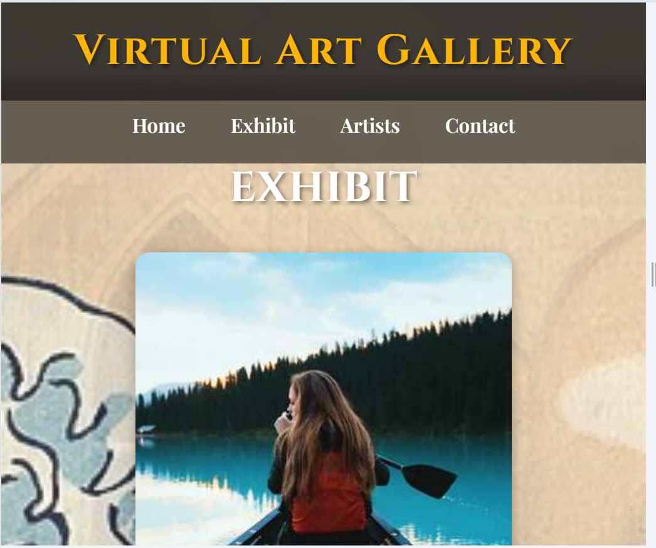

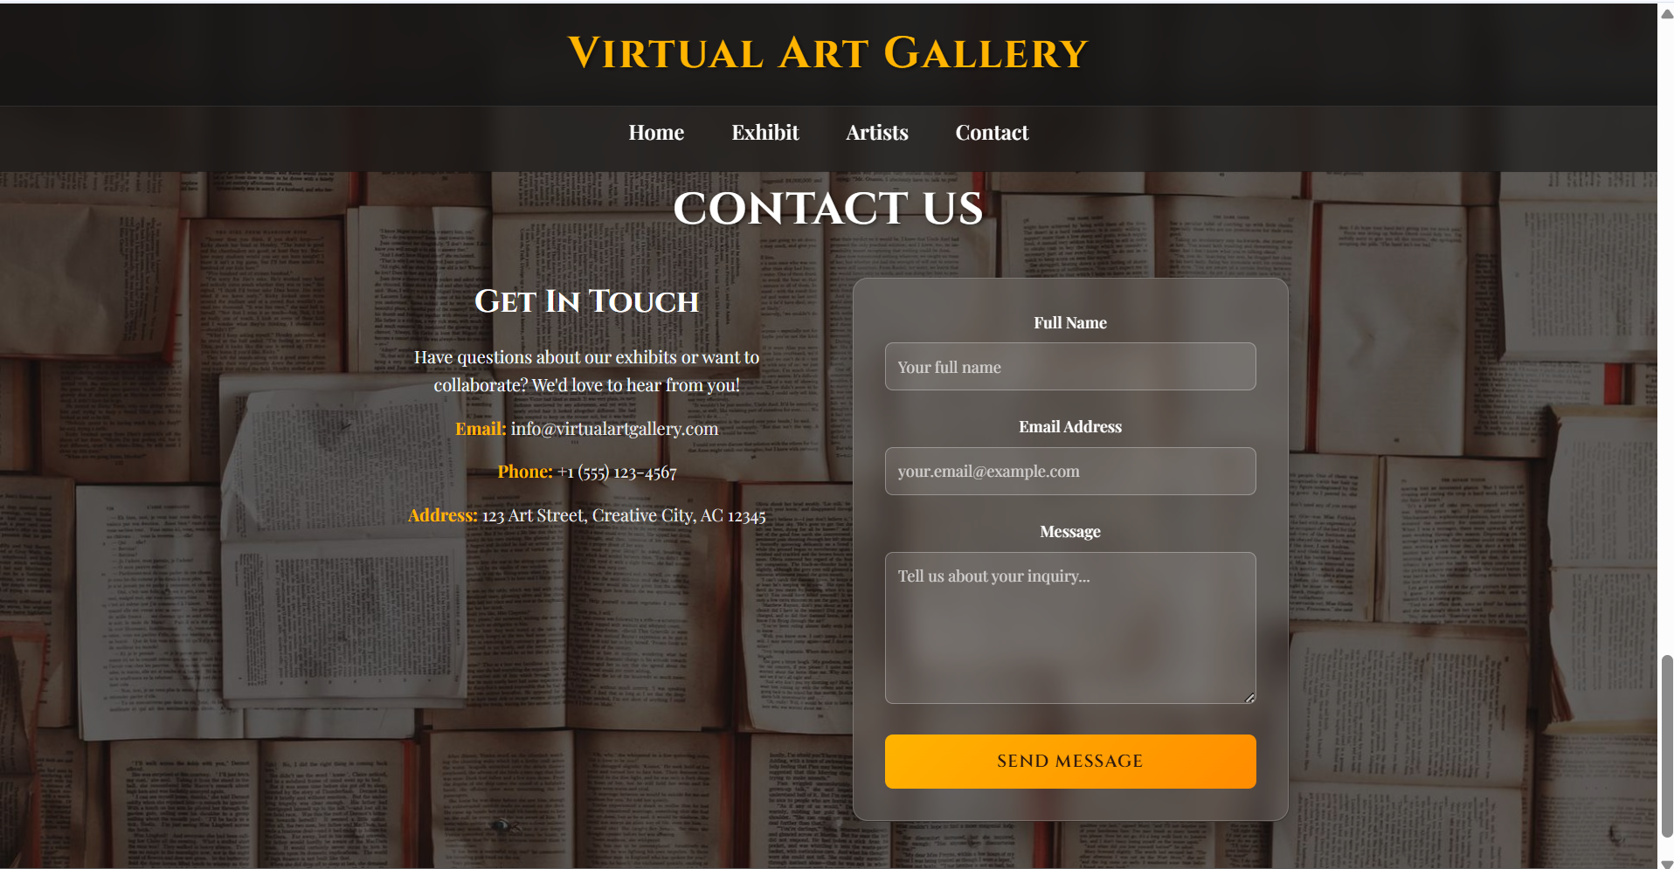

**Html:**

<!DOCTYPE html>

<html lang="en">

<head>

  <meta charset="UTF-8">

  <meta name="viewport" content="width=device-width, initial-scale=1.0">

  <title>Virtual Art Gallery</title>

  <link rel="preconnect" href="https://fonts.googleapis.com">

  <link rel="preconnect" href="https://fonts.gstatic.com" crossorigin>

  <link href="https://fonts.googleapis.com/css2?family=Playfair+Display:wght@400;500;600;700;800;900&family=Cinzel:wght@400;500;600;700;800;900&display=swap" rel="stylesheet">

  <link rel="stylesheet" href="style.css">

</head>

<body>

  <header class="site-header">

    <h1 class="main-heading">Virtual Art Gallery</h1>

  </header>

  <nav class="navbar">

    <ul>

      <li><a href="#home">Home</a></li>

      <li><a href="#exhibit">Exhibit</a></li>

      <li><a href="#artists">Artists</a></li>

      <li><a href="#contact">Contact</a></li>

    </ul>

  </nav>

  <section id="home" class="section home">

    <!-- Home Slideshow Background -->

    <div class="home-slideshow">

      <div class="home-slide active" style="background-image: url('https://picsum.photos/id/1018/1920/1080');"></div>

      <div class="home-slide" style="background-image: url('https://picsum.photos/id/1019/1920/1080');"></div>

      <div class="home-slide" style="background-image: url('https://picsum.photos/id/1020/1920/1080');"></div>

      <div class="home-slide" style="background-image: url('https://picsum.photos/id/1022/1920/1080');"></div>

      <div class="home-slide" style="background-image: url('https://picsum.photos/id/1024/1920/1080');"></div>

    </div>

    <div class="home-content">

      <h1>Welcome to the Virtual Art Gallery</h1>

      <p>Experience a unique journey through art, culture, and creativity. Our virtual platform brings together artists from around the world, showcasing works that inspire, challenge, and captivate.  </p>

      <p>From modern digital art to timeless classics, explore a collection designed to engage and connect.

        Enjoy the exhibition from the comfort of your home — accessible anytime, anywhere.</p>

    </div>

  </section>

  <section id="exhibit" class="section exhibit">

    <!-- Exhibit Slideshow Background -->

    <div class="exhibit-slideshow">

      <div class="exhibit-slide active" style="background-image: url('https://upload.wikimedia.org/wikipedia/commons/thumb/e/ec/Mona_Lisa%2C_by_Leonardo_da_Vinci%2C_from_C2RMF_retouched.jpg/1200px-Mona_Lisa%2C_by_Leonardo_da_Vinci%2C_from_C2RMF_retouched.jpg');"></div>

      <div class="exhibit-slide" style="background-image: url('https://upload.wikimedia.org/wikipedia/commons/thumb/e/ea/Van_Gogh_-_Starry_Night_-_Google_Art_Project.jpg/1280px-Van_Gogh_-_Starry_Night_-_Google_Art_Project.jpg');"></div>

      <div class="exhibit-slide" style="background-image: url('https://upload.wikimedia.org/wikipedia/commons/thumb/0/0a/The_Great_Wave_off_Kanagawa.jpg/1280px-The_Great_Wave_off_Kanagawa.jpg');"></div>

      <div class="exhibit-slide" style="background-image: url('https://upload.wikimedia.org/wikipedia/commons/thumb/c/cc/Grant_Wood_-_American_Gothic_-_Google_Art_Project.jpg/1280px-Grant_Wood_-_American_Gothic_-_Google_Art_Project.jpg');"></div>

      <div class="exhibit-slide" style="background-image: url('https://upload.wikimedia.org/wikipedia/en/d/dd/The_Persistence_of_Memory.jpg');"></div>

      <div class="exhibit-slide" style="background-image: url('https://upload.wikimedia.org/wikipedia/commons/thumb/0/0f/1665_Girl_with_a_Pearl_Earring.jpg/800px-1665_Girl_with_a_Pearl_Earring.jpg');"></div>

    </div>

    <div class="exhibit-container">

      <h1>Exhibit</h1>

      <div class="gallery">

        <figure>

          <img src="https://picsum.photos/id/1011/400/400" alt="Artwork 1">

          <figcaption>Artwork 1</figcaption>

        </figure>

        <figure>

          <img src="https://picsum.photos/id/1015/400/400" alt="Artwork 2">

          <figcaption>Artwork 2</figcaption>

        </figure>

        <figure>

          <img src="https://picsum.photos/id/1016/400/400" alt="Artwork 3">

          <figcaption>Artwork 3</figcaption>

        </figure>

        <figure>

          <img src="https://picsum.photos/id/1021/400/400" alt="Artwork 4">

          <figcaption>Artwork 4</figcaption>

        </figure>

        <figure>

          <img src="https://picsum.photos/id/1025/400/400" alt="Artwork 5">

          <figcaption>Artwork 5</figcaption>

        </figure>

        <figure>

          <img src="https://picsum.photos/id/1031/400/400" alt="Artwork 6">

          <figcaption>Artwork 6</figcaption>

        </figure>

      </div>

    </div>

  </section>

  <!-- Artists -->

  <section id="artists" class="section artists">

    <!-- Artists Slideshow Background -->

    <div class="artists-slideshow">

      <div class="artists-slide active" style="background-image: url('https://picsum.photos/id/1029/1920/1080');"></div>

      <div class="artists-slide" style="background-image: url('https://picsum.photos/id/1032/1920/1080');"></div>

      <div class="artists-slide" style="background-image: url('https://picsum.photos/id/1033/1920/1080');"></div>

      <div class="artists-slide" style="background-image: url('https://picsum.photos/id/1035/1920/1080');"></div>

    </div>

    <div class="artists-container">

      <h1>Featured Artists</h1>

      <div class="artist-list">

        <div class="artist-card">

          <img src="https://picsum.photos/id/1005/200/200" alt="Artist 1">

          <h3>Alex Morgan</h3>

          <p>Specializes in contemporary digital art and vibrant abstract designs.</p>

        </div>

        <div class="artist-card">

          <img src="https://picsum.photos/id/1001/200/200" alt="Artist 2">

          <h3>Sophia Chen</h3>

          <p>Creates traditional watercolor works blending nature and imagination.</p>

        </div>

        <div class="artist-card">

          <img src="https://picsum.photos/id/1000/200/200" alt="Artist 3">

          <h3>David Rossi</h3>

          <p>Focuses on modern photography with a cinematic storytelling approach.</p>

        </div>

      </div>

    </div>

  </section>

  <!-- Contact -->

  <section id="contact" class="section contact">

    <!-- Contact Slideshow Background -->

    <div class="contact-slideshow">

      <div class="contact-slide active" style="background-image: url('https://picsum.photos/id/1069/1920/1080');"></div>

      <div class="contact-slide" style="background-image: url('https://picsum.photos/id/1070/1920/1080');"></div>

      <div class="contact-slide" style="background-image: url('https://picsum.photos/id/1071/1920/1080');"></div>

      <div class="contact-slide" style="background-image: url('https://picsum.photos/id/1072/1920/1080');"></div>

      <div class="contact-slide" style="background-image: url('https://picsum.photos/id/1073/1920/1080');"></div>

    </div>

    <div class="contact-container">

      <h1>Contact Us</h1>

      <div class="contact-content">

        <div class="contact-info">

          <h2>Get In Touch</h2>

          <p>Have questions about our exhibits or want to collaborate? We'd love to hear from you!</p>

          <div class="contact-details">

            <p><strong>Email:</strong> info@virtualartgallery.com</p>

            <p><strong>Phone:</strong> +1 (555) 123-4567</p>

            <p><strong>Address:</strong> 123 Art Street, Creative City, AC 12345</p>

          </div>

        </div>

        <form class="contact-form" action="#" method="post">

          <div class="form-group">

            <label for="name">Full Name</label>

            <input type="text" id="name" name="name" required placeholder="Your full name">

          </div>

          <div class="form-group">

            <label for="email">Email Address</label>

            <input type="email" id="email" name="email" required placeholder="your.email@example.com">

          </div>

          <div class="form-group">

            <label for="message">Message</label>

            <textarea id="message" name="message" rows="6" required placeholder="Tell us about your inquiry..."></textarea>

          </div>

          <button type="submit" class="submit-btn">Send Message</button>

        </form>

      </div>

    </div>

  </section>

  <!-- Footer -->

  <footer class="footer">

    <p>&copy; 2025 Virtual Art Gallery | Designed for a seamless art experience</p>

  </footer>

  <script src="script.js"></script>

</body>

</html>

**Styles.css:**

/* Reset */

* {

  margin: 0;

  padding: 0;

  box-sizing: border-box;

}

body {

  font-family: 'Playfair Display', 'Times New Roman', serif;

  line-height: 1.6;

  scroll-behavior: smooth;

  background: #f4f4f4;

  color: #fff;

}

/* Site Header */

.site-header {

  position: fixed;

  top: 0;

  left: 0;

  right: 0;

  z-index: 1001;

  background: rgba(20, 20, 20, 0.8);

  backdrop-filter: blur(15px);

  padding: 1rem 2rem;

  text-align: center;

  border-bottom: 1px solid rgba(255, 255, 255, 0.1);

}

.main-heading {

  font-size: 2.8rem; /* Increased from 1.8rem */

  font-weight: 700;

  color: #ffb400;

  text-shadow: 2px 2px 4px rgba(0, 0, 0, 0.5);

  margin: 0;

  font-family: 'Cinzel', 'Times New Roman', serif;

  letter-spacing: 2px;

}

/* Navigation */

.navbar {

  position: fixed;

  top: 90px; /* Increased from 70px to accommodate larger header */

  width: 100%;

  background: rgba(20, 20, 20, 0.6);

  backdrop-filter: blur(12px);

  display: flex;

  justify-content: center;

  z-index: 1000;

}

.navbar ul {

  display: flex;

  list-style: none;

  padding: 1.5rem; /* Increased from 1rem to accommodate larger text */

}

.navbar li {

  margin: 0 1.5rem;

}

.navbar a {

  color: #fff;

  text-decoration: none;

  font-weight: 600;

  font-size: 1.3rem; /* Added larger font size */

  transition: color 0.3s;

}

.navbar a:hover {

  color: #ffb400;

}

/* Sections */

.section {

  min-height: 100vh;

  padding: 12rem 2rem 3rem; /* Increased from 10rem to accommodate larger header + nav */

  display: flex;

  flex-direction: column;

  align-items: center;

  text-align: center;

  position: relative;

}

/* Home Container */

.home-content {

  background: rgba(255, 255, 255, 0.15);

  backdrop-filter: blur(15px);

  border: 1px solid rgba(255, 255, 255, 0.2);

  border-radius: 20px;

  padding: 3rem 2rem;

  box-shadow: 0 8px 32px rgba(0, 0, 0, 0.3);

  max-width: 800px;

  margin: 8rem auto 2rem;

  position: relative;

  z-index: 2;

}

.home-content::before {

  content: '';

  position: absolute;

  top: 0;

  left: 0;

  right: 0;

  bottom: 0;

  background: linear-gradient(135deg, rgba(255, 255, 255, 0.1), rgba(255, 255, 255, 0.05));

  border-radius: 20px;

  z-index: -1;

}

/* Home Content Text Colors */

.home-content h1 {

  color: #ffffff;

  text-shadow: 2px 2px 4px rgba(0, 0, 0, 0.7);

  font-size: 3.2rem;

  margin-bottom: 1.5rem;

  font-weight: 800;

  font-family: 'Cinzel', 'Times New Roman', serif;

  letter-spacing: 1px;

  text-transform: uppercase;

}

.home-content p {

  color: #f0f8ff;

  text-shadow: 1px 1px 2px rgba(0, 0, 0, 0.5);

  font-size: 1.2rem;

  line-height: 1.7;

  font-weight: 400;

  font-style: italic;

}

/* Contact Slideshow Background */

.contact-slideshow {

  position: absolute;

  top: 0;

  left: 0;

  width: 100%;

  height: 100%;

  z-index: -1;

  overflow: hidden;

}

.contact-slide {

  position: absolute;

  top: 0;

  left: 0;

  width: 100%;

  height: 100%;

  background-size: cover;

  background-position: center;

  background-repeat: no-repeat;

  opacity: 0;

  transition: opacity 2s ease-in-out;

}

.contact-slide.active {

  opacity: 1;

}

/* Contact Overlay */

.contact-slideshow::after {

  content: '';

  position: absolute;

  top: 0;

  left: 0;

  right: 0;

  bottom: 0;

  background: rgba(0, 0, 0, 0.6);

  z-index: 1;

}

/* Contact Container */

.contact-container {

  position: relative;

  z-index: 2;

  max-width: 1000px;

  margin: 0 auto;

  padding: 0 2rem;

}

.contact-content {

  display: grid;

  grid-template-columns: 1fr 1fr;

  gap: 3rem;

  align-items: start;

  margin-top: 2rem;

}

.contact-info h2 {

  font-size: 2rem;

  margin-bottom: 1rem;

  color: #fff;

  font-family: 'Cinzel', 'Times New Roman', serif;

}

.contact-info p {

  font-size: 1.1rem;

  line-height: 1.6;

  margin-bottom: 1.5rem;

  color: #f0f8ff;

}

.contact-details p {

  margin-bottom: 0.5rem;

  font-size: 1rem;

  color: #e8e8e8;

}

.contact-details strong {

  color: #ffb400;

}

/* Contact Form */

.contact-form {

  background: rgba(255, 255, 255, 0.1);

  backdrop-filter: blur(15px);

  padding: 2rem;

  border-radius: 15px;

  border: 1px solid rgba(255, 255, 255, 0.2);

  box-shadow: 0 8px 32px rgba(0, 0, 0, 0.3);

}

.form-group {

  margin-bottom: 1.5rem;

}

.form-group label {

  display: block;

  margin-bottom: 0.5rem;

  font-weight: 600;

  color: #fff;

  font-size: 1rem;

}

.form-group input,

.form-group textarea {

  width: 100%;

  padding: 0.8rem;

  border: 1px solid rgba(255, 255, 255, 0.3);

  border-radius: 8px;

  background: rgba(255, 255, 255, 0.1);

  color: #fff;

  font-size: 1rem;

  font-family: 'Playfair Display', serif;

  transition: all 0.3s ease;

}

.form-group input::placeholder,

.form-group textarea::placeholder {

  color: rgba(255, 255, 255, 0.7);

}

.form-group input:focus,

.form-group textarea:focus {

  outline: none;

  border-color: #ffb400;

  background: rgba(255, 255, 255, 0.15);

  box-shadow: 0 0 0 3px rgba(255, 180, 0, 0.2);

}

.submit-btn {

  width: 100%;

  padding: 1rem;

  background: linear-gradient(135deg, #ffb400, #ff8c00);

  color: #2c1810;

  border: none;

  border-radius: 8px;

  font-size: 1.1rem;

  font-weight: 600;

  font-family: 'Cinzel', serif;

  cursor: pointer;

  transition: all 0.3s ease;

  text-transform: uppercase;

  letter-spacing: 1px;

}

.submit-btn:hover {

  transform: translateY(-2px);

  box-shadow: 0 6px 20px rgba(255, 180, 0, 0.4);

  background: linear-gradient(135deg, #ff8c00, #ffb400);

}

/* Home Slideshow */

.home-slideshow {

  position: absolute;

  top: 0;

  left: 0;

  width: 100%;

  height: 100%;

  z-index: 0;

}

.home-slide {

  position: absolute;

  top: 0;

  left: 0;

  width: 100%;

  height: 100%;

  background-size: cover;

  background-position: center;

  background-repeat: no-repeat;

  opacity: 0;

  transition: opacity 1.5s ease-in-out;

}

.home-slide.active {

  opacity: 1;

}

.slide {

  position: absolute;

  top: 0;

  left: 0;

  width: 100%;

  height: 100%;

  background-size: cover;

  background-position: center;

  background-repeat: no-repeat;

  opacity: 0;

  transition: opacity 1.5s ease-in-out;

}

.slide.active {

  opacity: 1;

}

/* Exhibit Slideshow */

.exhibit-slideshow {

  position: absolute;

  top: 0;

  left: 0;

  width: 100%;

  height: 100%;

  z-index: 0;

}

.exhibit-slide {

  position: absolute;

  top: 0;

  left: 0;

  width: 100%;

  height: 100%;

  background-size: cover;

  background-position: center;

  background-repeat: no-repeat;

  opacity: 0;

  transition: opacity 1.5s ease-in-out;

}

.exhibit-slide.active {

  opacity: 1;

}

/* Artists Slideshow */

.artists-slideshow {

  position: absolute;

  top: 0;

  left: 0;

  width: 100%;

  height: 100%;

  z-index: 0;

}

.artists-slide {

  position: absolute;

  top: 0;

  left: 0;

  width: 100%;

  height: 100%;

  background-size: cover;

  background-position: center;

  background-repeat: no-repeat;

  opacity: 0;

  transition: opacity 1.5s ease-in-out;

}

.artists-slide.active {

  opacity: 1;

}

/* Overlay for better text readability */

.slideshow::after {

  content: '';

  position: absolute;

  top: 0;

  left: 0;

  right: 0;

  bottom: 0;

  background: rgba(0, 0, 0, 0.4);

  z-index: 1;

}

/* Color Themes */

/* Contact section has slideshow background, no gradient needed */

/* Exhibit section has slideshow background, no gradient needed */

/* Artists section has slideshow background, no gradient needed */

/* Home Container */

.home-content {

  position: relative;

  z-index: 2;

  padding: 4rem 2rem;

  text-align: center;

}

/* Exhibit Container */

.exhibit-container {

  position: relative;

  z-index: 2;

  padding: 4rem 2rem;

  text-align: center;

}

/* Artists Container */

.artists-container {

  position: relative;

  z-index: 2;

  padding: 4rem 2rem;

  text-align: center;

}

/* Section Titles */

.section h1 {

  font-size: 2.8rem;

  margin-bottom: 1rem;

  font-weight: 700;

  font-family: 'Cinzel', 'Times New Roman', serif;

  letter-spacing: 1px;

  text-transform: uppercase;

  color: #fff;

  text-shadow: 2px 2px 4px rgba(0, 0, 0, 0.5);

}

.section p {

  max-width: 700px;

  margin-bottom: 1rem;

  font-weight: 400;

  font-size: 1.1rem;

  line-height: 1.6;

}

/* Gallery */

.gallery {

  display: grid;

  grid-template-columns: repeat(3, 1fr); /* 3 per row on desktop */

  gap: 1.5rem;

  margin-top: 2rem;

  width: 100%;

  max-width: 1200px;

}

.gallery figure {

  position: relative;

  overflow: hidden;

  border-radius: 15px;

  background: rgba(255, 255, 255, 0.1);

  backdrop-filter: blur(8px);

  box-shadow: 0 4px 15px rgba(0,0,0,0.3);

  transition: transform 0.3s ease;

}

.gallery img {

  width: 100%;

  height: auto;

  display: block;

  transition: transform 0.4s ease;

}

.gallery figure:hover img {

  transform: scale(1.1);

}

.gallery figcaption {

  padding: 0.7rem;

  background: rgba(0, 0, 0, 0.5);

  position: absolute;

  bottom: 0;

  width: 100%;

  color: #fff;

  font-size: 1rem;

  font-weight: bold;

  text-align: center;

}

/* Artist Cards */

.artist-list {

  display: flex;

  flex-wrap: wrap;

  gap: 2rem;

  margin-top: 2rem;

  justify-content: center;

}

.artist-card {

  background: rgba(255, 255, 255, 0.1);

  backdrop-filter: blur(10px);

  padding: 1.5rem;

  border-radius: 15px;

  width: 250px;

  box-shadow: 0 4px 12px rgba(0,0,0,0.3);

  transition: transform 0.3s;

}

.artist-card:hover {

  transform: translateY(-5px);

}

.artist-card img {

  border-radius: 50%;

  width: 100px;

  height: 100px;

  margin-bottom: 1rem;

}

.artist-card h3 {

  margin-bottom: 0.5rem;

  font-weight: 600;

  font-family: 'Cinzel', 'Times New Roman', serif;

  font-size: 1.3rem;

  letter-spacing: 0.5px;

}

/* Footer */

.footer {

  background: rgba(20, 20, 20, 0.7);

  backdrop-filter: blur(12px);

  text-align: center;

  padding: 1.5rem;

  color: #fff;

  font-size: 0.9rem;

  font-family: 'Playfair Display', 'Times New Roman', serif;

  font-weight: 500;

}

/* Responsive: 1 column on mobile */

@media (max-width: 768px) {

  .gallery {

    grid-template-columns: 1fr;

  }

  .artist-list {

    flex-direction: column;

    align-items: center;

  }

  .contact-content {

    grid-template-columns: 1fr;

    gap: 2rem;

  }

  .contact-form {

    padding: 1.5rem;

  }

}

**Script.js:**

// Slideshow functionality for multiple sections

document.addEventListener('DOMContentLoaded', function() {

    // Home Slideshow

    const homeSlides = document.querySelectorAll('.home-slide');

    let homeCurrentSlide = 0;

    function showHomeSlide(index) {

        homeSlides.forEach((slide, i) => {

            slide.classList.remove('active');

        });

        homeSlides[index].classList.add('active');

    }

    function nextHomeSlide() {

        homeCurrentSlide = (homeCurrentSlide + 1) % homeSlides.length;

        showHomeSlide(homeCurrentSlide);

    }

    if (homeSlides.length > 0) {

        showHomeSlide(0);

        setInterval(nextHomeSlide, 4000);

    }

    // Contact Slideshow

    const contactSlides = document.querySelectorAll('.contact-slide');

    let contactCurrentSlide = 0;

    function showContactSlide(index) {

        contactSlides.forEach((slide, i) => {

            slide.classList.remove('active');

        });

        contactSlides[index].classList.add('active');

    }

    function nextContactSlide() {

        contactCurrentSlide = (contactCurrentSlide + 1) % contactSlides.length;

        showContactSlide(contactCurrentSlide);

    }

    if (contactSlides.length > 0) {

        showContactSlide(0);

        setInterval(nextContactSlide, 4000);

    }

    // Exhibit Slideshow

    const exhibitSlides = document.querySelectorAll('.exhibit-slide');

    let exhibitCurrentSlide = 0;

    function showExhibitSlide(index) {

        exhibitSlides.forEach((slide, i) => {

            slide.classList.remove('active');

        });

        exhibitSlides[index].classList.add('active');

    }

    function nextExhibitSlide() {

        exhibitCurrentSlide = (exhibitCurrentSlide + 1) % exhibitSlides.length;

        showExhibitSlide(exhibitCurrentSlide);

    }

    if (exhibitSlides.length > 0) {

        showExhibitSlide(0);

        setInterval(nextExhibitSlide, 4000);

    }

    // Artists Slideshow

    const artistsSlides = document.querySelectorAll('.artists-slide');

    let artistsCurrentSlide = 0;

    function showArtistsSlide(index) {

        artistsSlides.forEach((slide, i) => {

            slide.classList.remove('active');

        });

        artistsSlides[index].classList.add('active');

    }

    function nextArtistsSlide() {

        artistsCurrentSlide = (artistsCurrentSlide + 1) % artistsSlides.length;

        showArtistsSlide(artistsCurrentSlide);

    }

    if (artistsSlides.length > 0) {

        showArtistsSlide(0);

        setInterval(nextArtistsSlide, 4000);

    }

});

// Form validation

document.addEventListener('DOMContentLoaded', function() {

    const contactForm = document.getElementById('contactForm');

    if (contactForm) {

        contactForm.addEventListener('submit', function(e) {

            e.preventDefault();

            const name = document.getElementById('name').value.trim();

            const email = document.getElementById('email').value.trim();

            const message = document.getElementById('message').value.trim();

            let isValid = true;

            let errorMessage = '';

            // Name validation

            if (name === '') {

                isValid = false;

                errorMessage += 'Name is required.\n';

            }

            // Email validation

            const emailRegex = /^[^\s@]+@[^\s@]+\.[^\s@]+$/;

            if (email === '') {

                isValid = false;

                errorMessage += 'Email is required.\n';

            } else if (!emailRegex.test(email)) {

                isValid = false;

                errorMessage += 'Please enter a valid email address.\n';

            }

            // Message validation

            if (message === '') {

                isValid = false;

                errorMessage += 'Message is required.\n';

            }

            if (isValid) {

                alert('Thank you for your message! We will get back to you soon.');

                contactForm.reset();

            } else {

                alert('Please correct the following errors:\n\n' + errorMessage);

            }

        });

    }

});